1.5.10 Packet Tracer - Verify Directly Connected Networks
Addressing Table
Device | Interface | IP Address/Prefix | Default Gateway
R1 | G0/0/0 | 172.16.20.1/25 | N/A
 | G0/0/1 | 172.16.20.129/25 | N/A
 | S0/1/0 | 209.165.200.225/30 | N/A
PC1 | NIC | 172.16.20.10/25 | 172.16.20.1
PC2 | NIC | 172.16.20.138/25 | 172.16.20.129
R2 | G0/0/0 | 2001:db8:c0de:12::1/64 | N/A
 | G0/0/1 | 2001:db8:c0de:13::1/64 | N/A
 | S0/1/1 | 2001:db8:c0de:11::1/64 | N/A
 |  | fe80::2 | N/A
PC3 | NIC | 2001:db8:c0de:12::a/64 | fe80::2
PC4 | NIC | 2001:db8:c0de:13::a/64 | fe80::2

Objectives
- Verify IPv4 Directly Connected Networks
- Verify IPv6 Directly Connected Networks
- Troubleshoot connectivity issues.

Background
Routers R1 and R2 each have two LANs. Your task is to verify the addressing on each device and verify connectivity between the LANs.
Note: The user EXEC password is cisco. The privileged EXEC password is class.

Instructions

Part 1: Verify IPv4 Directly Connected Networks

Step 1: Verify IPv4 addresses and port status on R1.
- Check the status of the configured interfaces by filtering the output.
R1# show ip interface brief | exclude unassigned
R1 > CLI  Password: cisco  R1>enable  Password: class  R1#show ip interface brief | exclude unassigned | 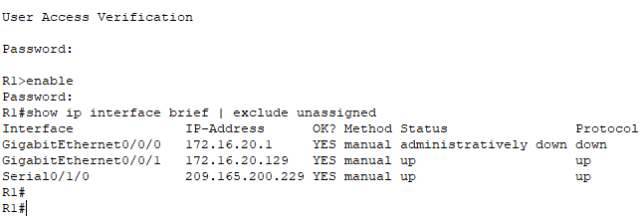

- Based on the output, correct any port status problems that you see.

GigabitEthernet 0.0.0 got a status problem. The status is administratively down.  R1#configure terminal  R1(config)#int g 0/0/0  R1(config-if)#no shutdown  R1(config)#^Z  R1#show ip interface brief | exclude unassigned | 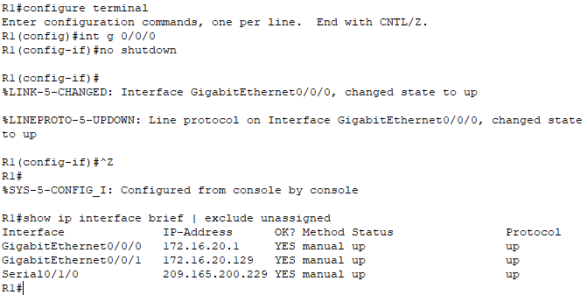

- Refer to the Addressing Table and verify the IP addresses configured on R1. Make any corrections to address if necessary.

R1#show running-config | 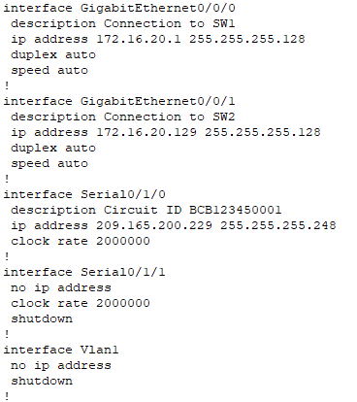
The interface serial 0/1/0 is incorrect. The ip address and subnet mask are incorrect. The correct ip address is 209.165.200.225 and subnet mask is 255.255.255.252 | 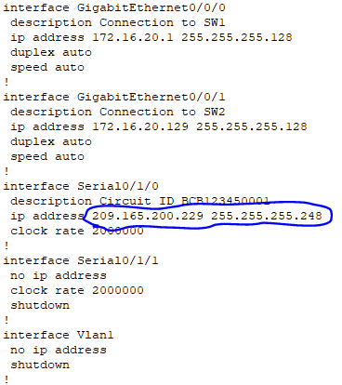
R1#config terminal  R1(config)#int s 0/1/0  R1(config-if)#ip address 209.165.200.225 255.255.255.252  R1(config-if)#^Z  R1#show running-config | 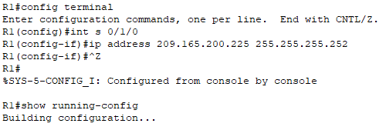  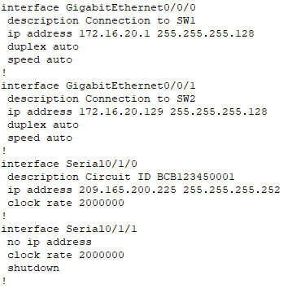

- Display the routing table by filtering to start the output at the word Gateway.
Note: Terms that are used to filter output can be shortened to match text as long as the match is unique. For example, Gateway, Gate, and Ga will have the same effect. G will not. Filtering is case-sensitive
R1# show ip route | begin Gate
What is the Gateway of last resort address?

R1#show ip route | begin Gate  Gateway of last resort is 209.165.200.226 to network 0.0.0.0 | 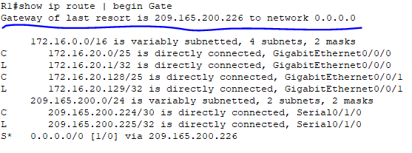

- Display interface information and filter for Description or connected.
Note: When using include or exclude multiple searches can be performed by separating the search strings with a pipe symbol ( | )
R1# show interface | include Desc|conn
What is the Circuit ID displayed from your output?

R1#show interface | include Desc|conn  The circuit ID is BCB123450001 | 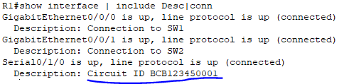

- Display specific interface information for G0/0/0 by filtering for duplex.
What is the duplex setting, speed, and media type?

R1#show int g 0/0/0  Duplex setting is Full-duplex,speed is 100Mb/s and media type is RJ45 | 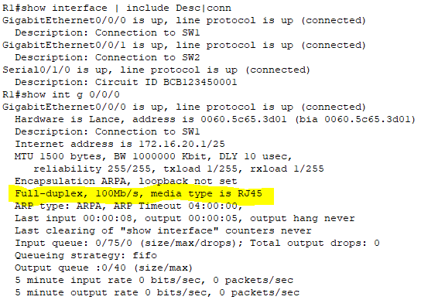

Step 2: Verify connectivity.
PC1 and PC2 should be able to ping each other and the Dual Stack Server. If not, verify the status of the interfaces and the IP address assignments.

PC1 > Command Prompt  C:\>ping 172.16.20.138  C:\>ping 64.100.1.10 | 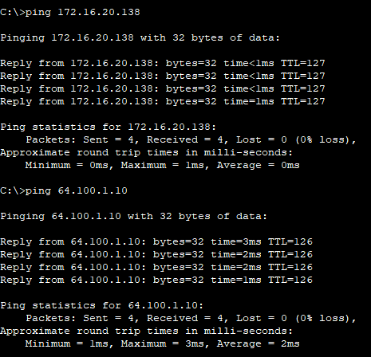
PC2 > Command Prompt  C:\>ping 172.16.20.10  C:\>ping 64.100.1.10 | 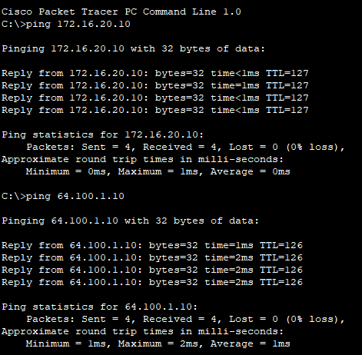

Part 2: Verify IPv6 Directly Connected Networks

Step 1: Verify IPv6 addresses and port status on R2.
- Check the status of the configured interfaces.
R2# show ipv6 int brief
What is the status of the configured interfaces?

R2 > CLI  - Password: cisco  - R1>enable  - Password: class  - R2#show ipv6 interface brief  The ipv6 gigabitEthernet 0/0/1is wrong and also the ipv6 link local serial 0/1/1 is also wrong. | 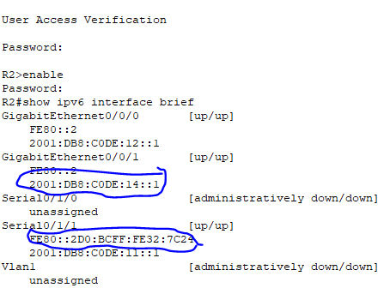

- Refer to the Addressing Table and make any corrections to addressing as necessary.
Note: When changing an IPv6 address it is necessary to remove the incorrect address since an interface is capable of supporting multiple IPv6 networks.
R2(config)# int g0/0/1
R2(config-if)# no ipv6 address 2001:db8:c0de:14::1/64
Configure the correct address on the interface.

R2#configure terminal  R2(config)#int g 0/0/1  R2(config-if)#no ipv6 address 2001:DB8:C0DE:14::1/64  R2(config-if)#ipv6 address 2001:DB8:C0DE:13::1/64  R2(config-if)#exit | 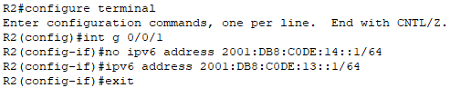
R2(config)#int s 0/1/1  R2(config-if)#ipv6 address fe80::2 link-local  R2(config-if)#^Z | 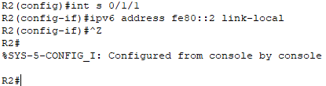

- Display the IPv6 routing table.
Note: Filtering commands do not presently work with the IPv6 commands.

R2#show ipv6 route | 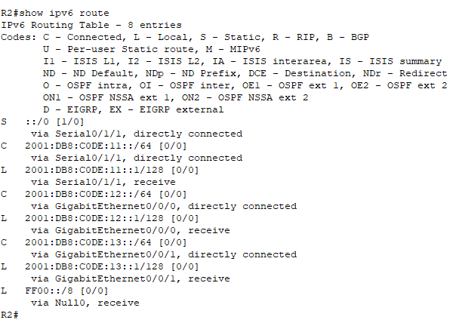

- Display all IPv6 addressing configured on interfaces by filtering the output of the running-config.
Filter the output on R2 for ipv6 or interface.
R2# sh run | include ipv6|interface
How many addresses are configured on each Gigabit interface?

R2#show running-config | include ipv6|interface  Total has 2 addresses on each Gigabit interface. | 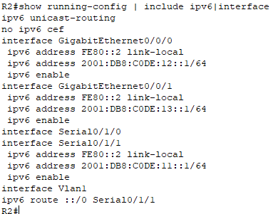

Step 2: Verify connectivity.
PC3 and PC4 should be able to ping each other and the Dual Stack Server. If not, verify the interface status and IPv6 address assignments.

PC3 > Command Prompt  C:\>ping 2001:db8:c0de:13::a  C:\>ping 2001:db8:100:1::a | 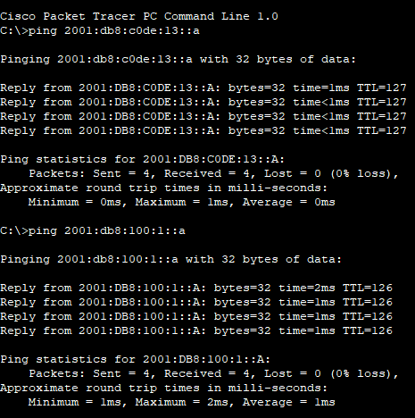
PC4 > Command Prompt  C:\>ping 2001:db8:c0de:12::a  C:\>ping 2001:db8:100:1::a | 